Croftlands Infant and Nursery School

**Early Years Curriculum**

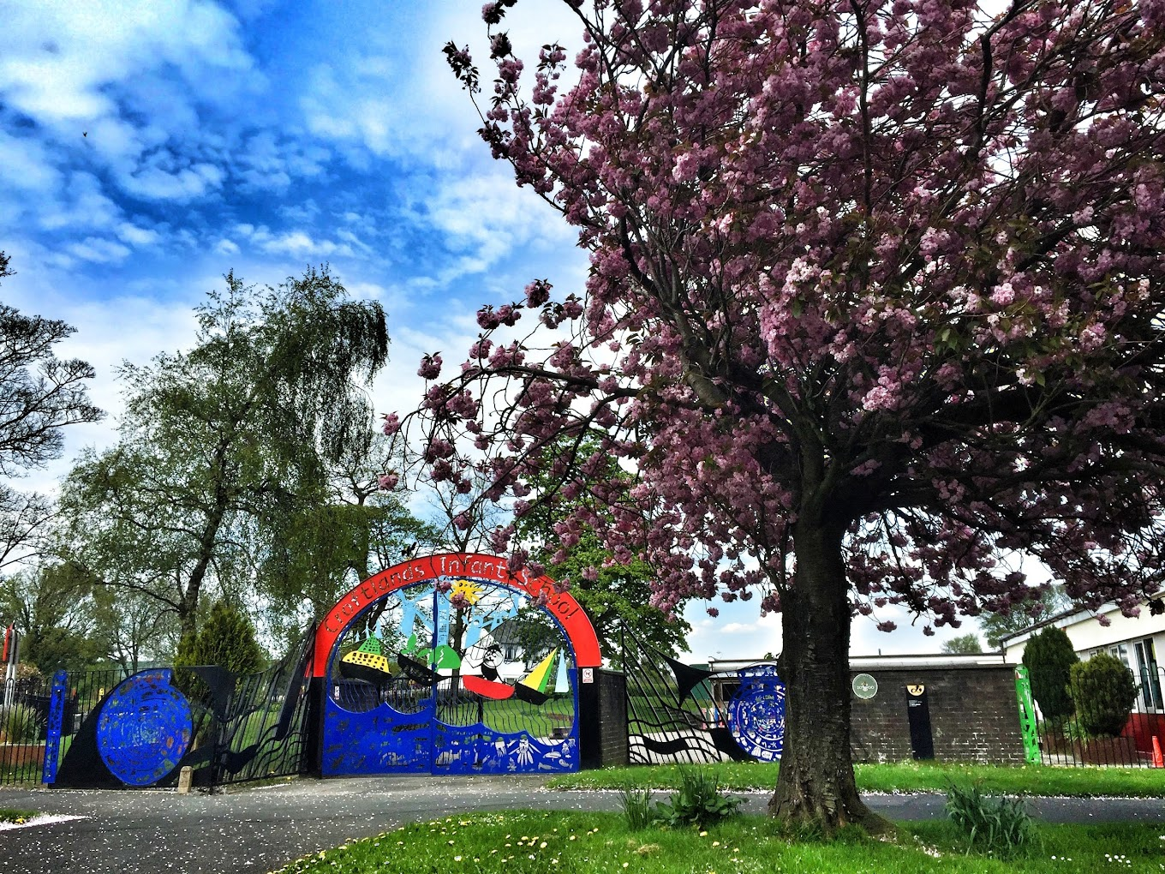

The Early Years Team has devised our own unique curriculum. There is an individual curriculum for each year which overlaps with the next year group, creating our own Early Year curriculum. This is a sequenced document, showing progression from one year group to the next with reference to the developmental stages in the Birth to 5 Matters document. The sequence of learning will support our children to progress at the stage they are developing within.

Our curriculum reflects the uniqueness of the children who attend our school. We live in a small market town with a strong sense of community, there are many local festivals and events that families attend throughout the year. We have the Lake District on our doorstep as well as the coast providing easy access to outdoor spaces where children can be absorbed in nature. We share and incorporate these interests into the activities we plan to deliver our curriculum. We also have a wonderful outdoor space here at school with a large field, a wild wooded area and three separate playgrounds.

|  |  |  |  |  |  |  |
| --- | --- | --- | --- | --- | --- | --- |
| **Wrens Room. 3 months - 2 Years** | | | | | | |
|  | **Autumn 1**  **Sept - Oct** | **Autumn 2**  **Nov – Dec** | **Spring 1**  **Jan – Feb** | **Spring 2**  **Mar – Apr** | **Summer 1**  **May - Jun** | **Summer 2**  **Jul - Aug** |
| **Themes and Topics** | **The children’s progression through the curriculum is taught by following the changing seasons and is flexible to respond to children’s interests, making the most of opportunities that arise.** | | | | | |
| **Songs and Rhymes**  **(Not limited to)** | Miss Polly had a Dolly  Teddy bear, Teddy bear.  Grand old duke of York.  Wind the Bobbin up. | 5 Little Leaves.  Dingls, Dangle Scarecrow.  5 Little Pumpkins.  Christmas Songs. | Miss Polly.  5 Current Buns.  If you’re Happy and you know it.  5 Little Monkeys.  Wind the Bobbin up | 5 Little Ducks.  5 speckled Frogs.  Mary had a little lamb.  Sleeping Bunnies.  Baa, baa black sheep. | Rain, rain go away.  Row, row, row your boat.  Wheels on the Bus.  If you’re happy and you know it. | Baby Shark.  5 Jellyfish.  Head, shoulders, knees and toes. |
| **Festivals and Important days.** | Harvest Festival  Lantern Festival (Local)  Halloween | Bonfire Night.  Divali.  Remembrance Day.  Christmas. | Chinese New Year  Valentines Day.  St David’s Day.  Shrove Tuesday. | Mother’s Day  Easter  World Book Day | World Bee Day  Father’s Day  St George’s Day. | Shark Awareness Day  Carnival Day (Local)  International Cat Day  International Dog Day |
| **Stories and Books**  **(Not limited to)** | We’re going on a Bear hunt.  Autumn Babies. | The Gruffalo.  Dear Zoo.  Little Acorns.  Pumpkin Pie. | The Very Hungry Caterpillar.  The Itsy Bitsy Snowman. | Over on the Farm.  That’s not my Bunny.  We’re going on an egg hunt. | Little Blue Truck.  Thimgs that go dig, dig, digging.  Busy beach. | The Little Ice cream truck.  Fran’s Flower.  Sharing a Shell |

**Personal, Social and Emotional Development**

Children’s personal, social and emotional development (PSED) is crucial for children to lead healthy and happy lives and is fundamental to their cognitive development. Underpinning their personal development are the important attachments that shape their social world. Strong, warm and supportive relationships with adults enable children to learn how to understand their own feelings and those of others. Children should be supported to manage emotions, develop a positive sense of self, set themselves simple goals, have confidence in their own abilities, to persist and wait for what they want and direct attention as necessary. Through adult modelling and guidance, they will learn how to look after their bodies, including healthy eating, and managing personal needs independently. Through supported interaction with other children, they learn how to make good friendships, co-operate and resolve conflicts peaceably. These attributes will provide a secure platform from which children can achieve at school and in later life.

|  |  |  |  |  |  |
| --- | --- | --- | --- | --- | --- |
| **Wren Room. 3 months – 2 years.** | | | | | |
| **Steps of Progression >>>>>>>>>>>>>>>>>>>>>>>>>>>>>>>>>>>>>>>>>>>>>>>>>>>>>>>>>>>>>>>>>>>>>>>>>>>>>>>>>>>>>>>>>>>>>>>>>>>** | | | | | |
| * Enjoy the company of others. * Seek physical support and emotional comfort by snuggling in. | * Begin to get attached to familiar adults and shows separation anxiety. * Like to look at their own reflection and mirrors, engages in mirror play. | * Build relationships with special people and their keyworkers. * Use comfort objects to help soothe themselves. | * Is wary of unfamiliar people. * Begin to be aware of familiar routines. | * Engage other adults to help get something that is out of reach by guiding and to achieve a goal. * Enjoy finding their own facial features in naming games. | * Explore the environment, interact with others and play confidently whilst their key person is close by. * To show their growing sense of self through asserting their likes/dislikes, choices, decisions and ideas. |
| **Vocabulary.**  Babbling. Eyes, nose, mouth, kind, gentle, care, love, me, you, share, yes, no. Names of familiar people/family members. | | | | | |
| **Implementation**  Modelling good behaviour, kindness and helping children manage emotions. Mirror play. One-to-one interactions, eye contact. Rolling a ball to and fro with a familiar adult. Use the role play area to model pretend play. Bathing dolls. | | | | | |

**Physical development**

By creating games and providing opportunities for play both indoors and outdoors, adults can support children to develop their core strength, stability, balance, spatial awareness, co-ordination and agility. Gross motor skills provide the foundation for developing healthy bodies and social and emotional well-being. Fine motor control and precision helps with hand-eye co-ordination which is later linked to early literacy. Repeated and varied opportunities to explore and play with small world activities, puzzles, arts and crafts and the practice of using small tools, with feedback and support from adults, allow children to develop proficiency, control and confidence.

|  |  |  |  |  |  |
| --- | --- | --- | --- | --- | --- |
| **Wren Room. 3 months – 2 years.** | | | | | |
| **Steps of Progression >>>>>>>>>>>>>>>>>>>>>>>>>>>>>>>>>>>>>>>>>>>>>>>>>>>>>>>>>>>>>>>>>>>>>>>>>>>>>>>>>>>>>>>>>>>>>>>>>>>** | | | | | |
| * Follows and tracks sound and moving objects. * Begin to communicate through facial expressions and body movements. * Opens mouth for food. * Rolls over from front to back. | * Begin to bang, shake, pull and tug objects that they pick up in both hands exploring sounds made. * Explore fingers and toe rhyming games. * Co-operate with nappy changing and dressing. * Begins to sit unaided. | * Enjoy sensory experiences through making marks in damp sand, gloop, oats, soil. * Move their whole body to songs and rhymes. * Belly crawling * Moves to crawling on hands and knees. | * Show interest in rhymes and songs beginning to join in with actions to songs that they recognise. * Begin to feed themselves with a spoon (sometimes missing their mouth). * Pull themselves up from sitting to standing holding on to a fixed onject * Begin to ‘cruise’ around furniture. | * Make sounds with objects and actively respond to music. * Show an interest in dressing and undressing themselves. * Manipulate objects using their hands such as squishing playdough. * Begin to walk unaided with growing confidence. * Begin to throw and release objects over arm. | * Use gestures and body language to convey needs and interests. * Gradually gain control of their whole bodies through practising ‘big’ movements (waving, kicking, walking) * Turn pages in a book, sometimes several at once. * Hold a cup with both hands and guide to their mouth. |
| **Vocabulary**  Big, little, climb, run, throw, catch, walk, more, crawl, ball, slide. Names of foods and cutlery. Wash, hands, nappy, change, eat. | | | | | |
| **Implementation**  Quality interations between staff and children during meal times, snack times, changing times. Play within the soft play area, climbing on cushions using the steps and slide indoors. Supervised exploration outdoors. Big build construction activities. Mark making opportunities within sensory play sessions. Messy tuff tray activities. | | | | | |

**Communication and Language**

The development of children’s spoken language underpins all seven areas of learning and development. Children’s back-and-forth interactions from an early age form the foundations for language and cognitive development. The number and quality of the conversations they have with adults and peers throughout the day in a language-rich environment is crucial. By commenting on what children are interested in or doing, and echoing back what they say with new vocabulary added, practitioners will build children's language effectively. Reading frequently to children, and engaging them actively in stories, non-fiction, rhymes and poems, and then providing them with extensive opportunities to use and embed new words in a range of contexts, will give children the opportunity to thrive. Through conversation, story-telling and role play, where children share their ideas with support and modelling from staff, and sensitive questioning that invites them to elaborate, children become comfortable using a rich range of vocabulary and language structures.

|  |  |  |  |  |  |
| --- | --- | --- | --- | --- | --- |
| **Wren Room. 3 months – 2 years** | | | | | |
| **Steps of Progression >>>>>>>>>>>>>>>>>>>>>>>>>>>>>>>>>>>>>>>>>>>>>>>>>>>>>>>>>>>>>>>>>>>>>>>>>>>>>>>>>>>>>>>>>>>>>>>>>>>** | | | | | |
| * Turn towards familiar sounds with accuracy. * React during interaction with others by smiling, looking and moving. * Lift their arms in anticipation to be picked up. | * Point to objects to share an interest. * Listen to familiar sounds and words when spoken to/with, during stories and singing. | * Enjoy songs and rhymes and move their whole body to music. * Enjoy laughing with peers and begin to be palyful with others. | * Use sounds in play, (Brrrrm for a car) as single words beging to develop. * Begin to concentrate on activities that interest them for short periods of time. | * Create personal words as language begins to develop. * Respond to simple questions when asked. * Enjoy rhymes and begin to copy familiar actions to songs. | * Use single words * Understand simple sentences. * Respond to simple questions such what, who, where. * Begin to sit and listen to short stories. * Attempt to communicate with peers both non-verbally and verbally. |
| **Vocabulary**  Babbling. Bye, Hello, More, Mummy, Daddy (names of friends, family and staff). Animal sounds. Words in familiar rhymes and songs. | | | | | |
| **Implementation**  Quality interactions between key person and child – Repetition, narrating during play and daily routines, naming objects, toys, places. Singing songs and reading short stories. Mirror play.  Consistency with daily routines.  Sharing All About Me books with children. | | | | | |